29.20: a)
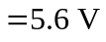
b) (i)
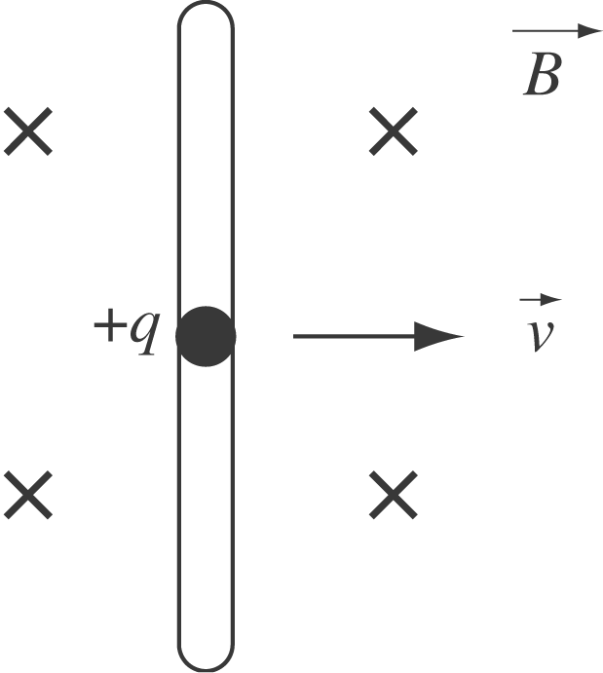
Let q be a positive charge in the moving bar. The magnetic force on this charge 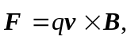 which points upward. This force pushes the current in a counterclockwise direction through the circuit.
(ii) The flux through the circuit is increasing, so the induced current must cause a magnetic field out of the paper to oppose this increase. Hence this current must flow in a
counterclockwise sense.
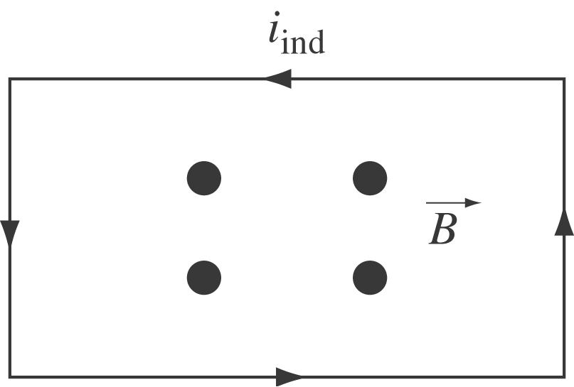
c) 